Industry Internship Report

On

**Smart City ecosystem using IoT**

Submitted to:

**Amity University Uttar Pradesh, Noida**



In partial fulfilment of the requirements for the awards of the degree

B.Tech (Information Technology)

By

**Rajan Goel (A12405316018)**

Under the guidance of

**Dr. Saru Dhir**

Department of Information Technology

Amity School of Engineering and Technology

Amity University Uttar Pradesh, Noida

**ACKNOWLEDGEMENT**

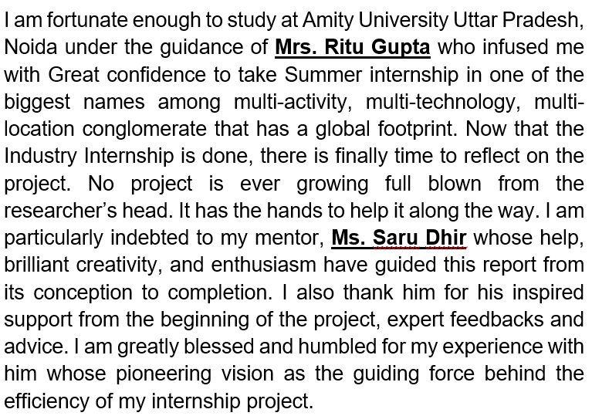

Rajan Goel

A12405316018

ASET

B.Tech

(Information Technology)

**DECLARATION**

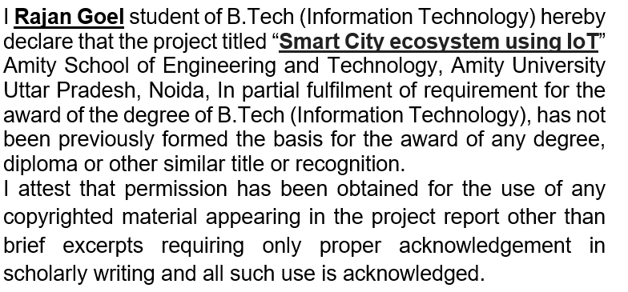

________________

Signature

Rajan Goel

A12405316018

Date _____________

**CERTIFICATE**

This is to certify that Rajan Goel, student of B. Tech. (Information Technology) has carried out the work presented in the Industry Internship Project entitle "**Smart City ecosystem using IoT**" as a part of Fourth year program of B.Tech(Information Technology) from Amity School of Engineering and Technology, at Amity University Uttar Pradesh, Noida under my supervision.

___________________

Ms. Saru Dhir

Assistant Professor

Department of Information Technology

Amity School of Engineering & Technology

**ABSTRACT**

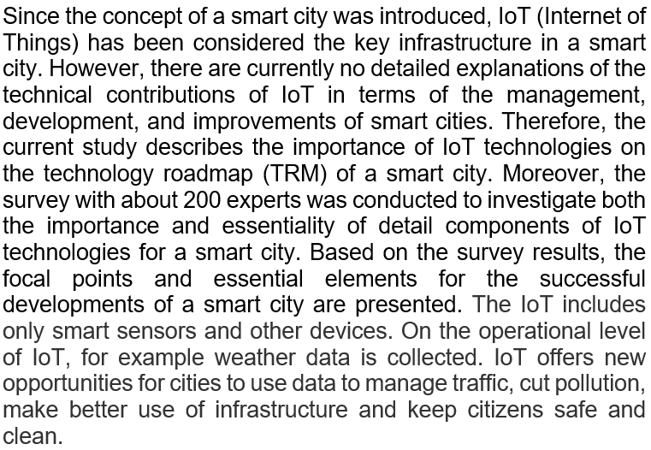

**CONTENTS**

|  |  |  |
| --- | --- | --- |
| S.No. | Topics | Page No. |
|  | Introduction | 07 |
|  | Internet of Things (IoT) | 08 |
|  | What is a smart city? Difference from regular cities ? | 09 |
|  | How is IoT technology making towns smarter and better? | 10 |
|  | What makes smart cities successful | 11 |
|  | Role of the smartphone in IoT | 11 |
|  | IoT use cases for smart cities | 12 |
|  | Smart Cities Map | 15 |
|  | Implementation challenges for smart cities in India | 16 |
|  | Conclusion | 20 |
|  | References | 21 |

1. **INTRODUCTION**

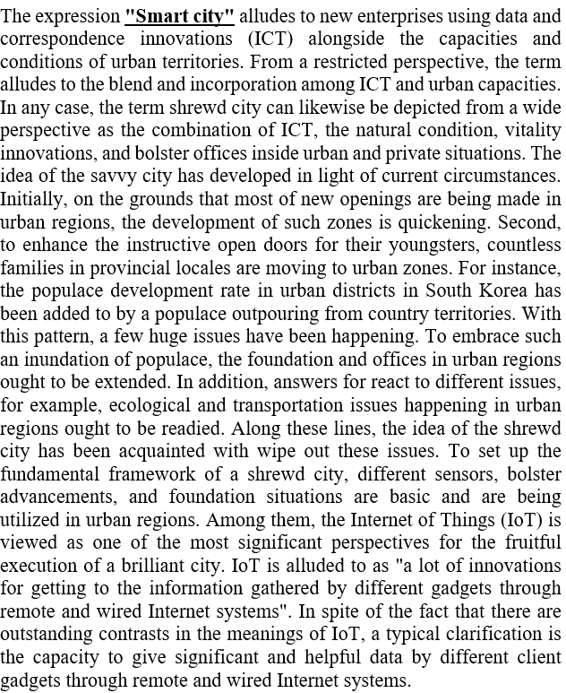

**2. INTERNET OF THINGS**

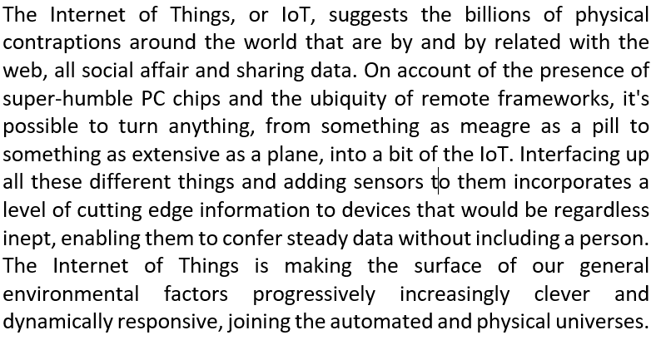

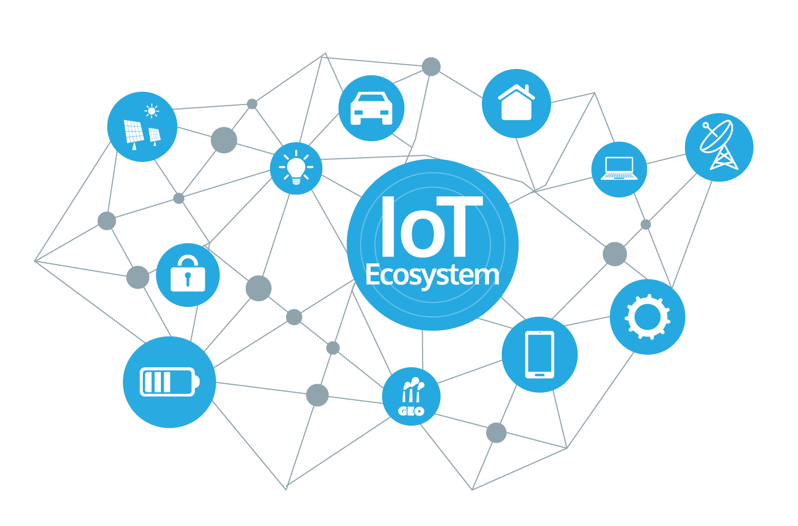

1. **What is a smart city? How it is different from regular cities in India?**

In the past 2-3 years, smart cities development has been touted as one of biggest infrastructure projects by the government. It is being called one of the best ways to make “India smarter”. The development of a smart city comprises smart urban planning, good working environment and sufficient provisions for utilities. The advancement of a smart city depends on the growth of its progression. The theory of smart is not complex. There are many speculations are surrounded on how the smart city project will come into completion. Importantly, citizens also need to accept the concept of smart city. The origin of a smart city comes within the existing cities of India. The developmental approach and how we are accepting the change is something to look forward to. Vikas Sharma, CEO, Spectrum@Metro says “developing Smart Cities will be like revamping the existing ones into better and much proficient cities that will not only promote growth of the region but provide a better living style to its residents.” All the listed smart cities under PM Narendra Modi’s pet project endorse complete growth of that region. Every developmental approach will majorly concern its residents.

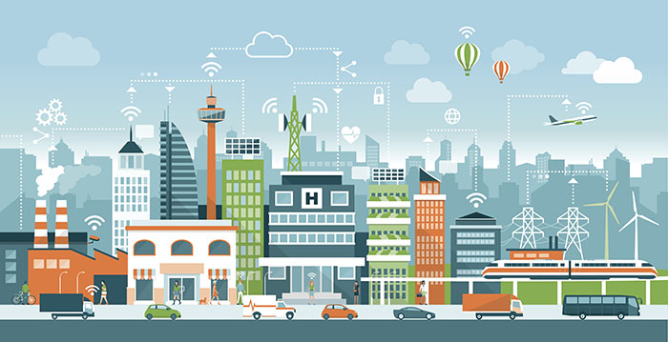

1. **How is IoT technology making towns smarter and better?**

Secure faraway network and IoT innovation are converting customary additives of town lifestyles - like streetlights - into cutting edge savvy lighting fixtures levels with prolonged abilities.

The extension incorporates coordinating sun powered force and interfacing with a cloud-based focal control framework that associates with different resources in the biological system.

These arrangements sparkle a long ways past straightforward lighting needs.

• High-power inserted LEDs ready workers about traffic issues, give extreme climate admonitions, and give heads up when natural like fires emerge.

• Streetlights can likewise perceive unfastened parking spots and EV charging ports and prepared drivers where to find an open spot via a transportable software program. Charging can also be effective from the mild positioned up itself in certain regions!

**5. What makes smart cities successful**

Notwithstanding individuals, residences, business, and customary urban foundation, there are four fundamental components important for flourishing keen urban communities:

1. Pervasive remote availability

2. Open information

3. Security you can trust in

4. Flexible adaptation plans

**6.Role of the smartphone in IoT**

• IoT for the normal individual is the cell phone since it will be all over the place and everybody conveys a cell phone the entire day

• We use it for countless day by day undertakings to connect with other savvy gadgets

• Interaction with IoT utilizing a cell phone just in light of the fact that this is the figuring stage that we are well on the way to have with us anytime

• Concerned that something isn't exactly directly with our IoT-empowered gadget (for example at the point when your own vehicle got a "Check Engine" light), we will have the option to run an expert vehicle examine indicative apparatus from our cell phone to peruse symptomatic difficulty codes which is less expensive than carrying it to an expert auto technician to analyze the issue

• IoT implies that shoppers will have more choices with regards to brilliant gadgets (connection with those gadgets through the cell phone)

• More potential outcomes like associating your cell phone with a clothes washer to get a diagram to see the water use and power in the course of recent weeks/months

• In all, every IoT gadget, for example, clothes washers, fridges or vehicles can send and get information to extraordinarily arranged servers on the Internet – they can associate and impart over the Internet.

## 7. IoT use cases for smart cities

IoT-empowered top-notch metropolis use instances period precise territories: from adding to a extra beneficial situation and improving web page traffic to upgrading open wellness and streamlining road lighting. Underneath, we supply an define of the most famous use instances which are as of now actualized in intelligent metropolis businesses over the globe.

**7.1 Road traffic**

Smart Cities assure that their residents get from guide A in the direction of point B as securely and proficiently as may want to reasonably be expected. To accomplish this, districts visit IoT development and execute keen site visitors preparations.

Keen visitors preparations employ numerous kinds of sensors, certainly as bring GPS records from drivers' advanced cells to decide the range, vicinity and the rate of motors. Simultaneously, keen visitors lighting associated with a cloud the board level permit checking inexperienced mild timings and consequently change the lighting fixtures depending on cutting-edge visitors situation to forestall blockage. Furthermore, utilizing actual statistics, extraordinary solutions for website online visitors the board can foresee where the traffic may want to proceed to take measures to stop ability blockage.

**7.2 Smart parking**

With the assistance of GPS records from drivers' cellular phones (or avenue ground sensors implanted within the floor on parking areas), sensible preventing preparations determine if the parking spaces are worried or reachable and make an ongoing stopping map. At the element when the closest parking area seems to be unfastened, drivers get a be conscious and utilize the manual on their phone to find out a parking region quicker and less complicated rather than indiscriminately driving spherical.

### **7.3 Street lighting**

### IoT-based totally completely Smart cities make resource and manipulate of road lighting more and more smooth and realistic. Outfitting streetlights with sensors and associating them to a cloud the board affiliation assists with adjusting lights calendar to the lighting fixtures sector.

### Brilliant lighting arrangements gather records on illuminance, improvement of human beings and automobiles, and be part of it with chronicled and relevant information (e.G., first-rate sports, open automobile plan, time of day and 365 days, and so forth.) and inspect it to enhance the lights plan. Subsequently, a eager lighting affiliation "tells" a streetlight to decrease, mild up, set off or switch off the lighting depending on the out of doors conditions.

### **7.4** **Waste management**

Most waste assortment directors void holders as consistent with predefined plans. This is really no longer a totally proficient approach as it turns on the inefficient utilization of waste booths and needless fuel usage through squander accumulating vans.

IoT-empowered eager metropolis arrangements help to beautify squander amassing plans with the useful resource of following waste ranges, simply as giving direction streamlining and operational investigation. Each waste compartment gets a sensor that assembles the facts about the degree of the loss in a holder. When it's miles close to a particular part, the waste management affiliation receives a sensor document, paperwork it, and sends a caution to a truck driver's transportable software. Consequently, the truck riding pressure exhausts a whole holder, abstaining from discharging half-full ones.

|  |
| --- |
| iot applications for smart cities of different sizes |

**8. Smart Cities Map**

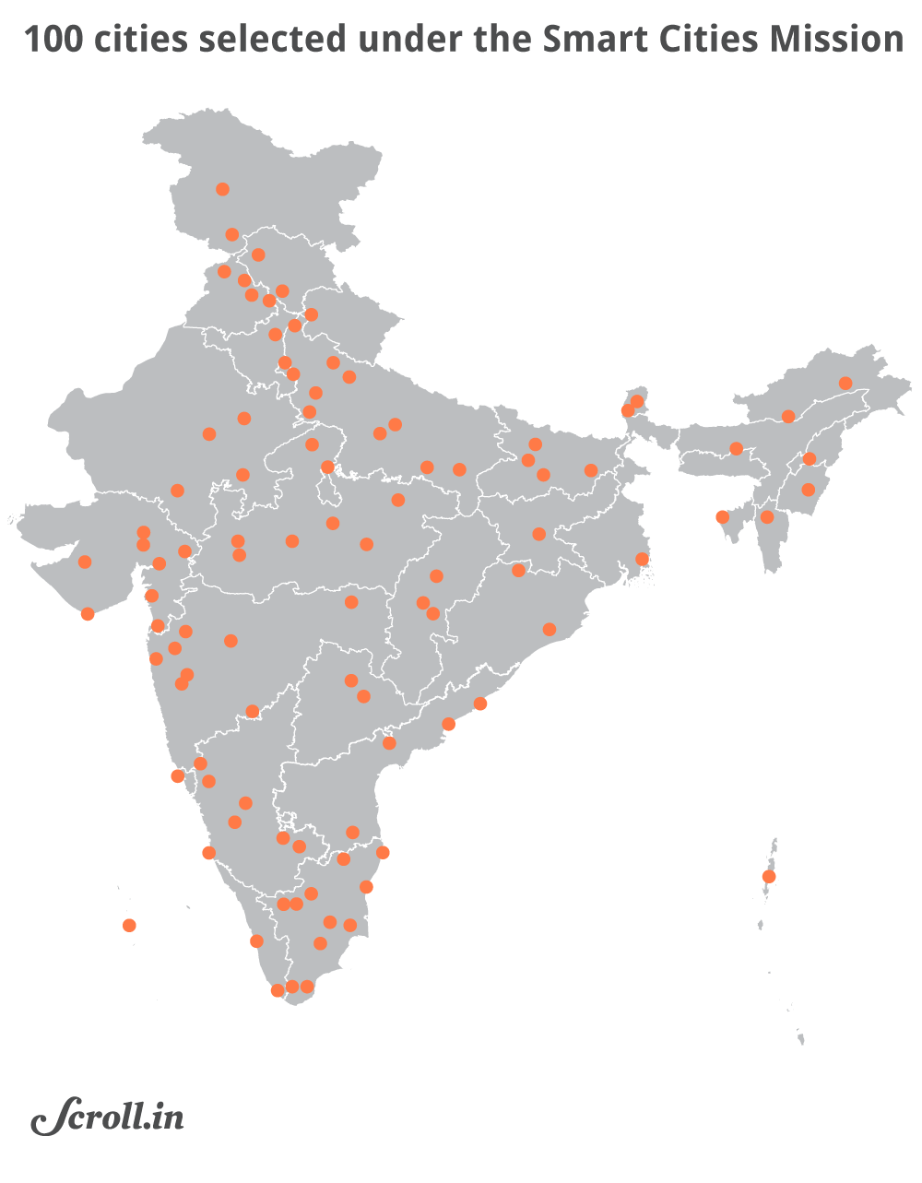

|  |  |
| --- | --- |
| 1st Round | Selection of 20 Smart Cities. |
| 2nd Round | Selection of 13 Smart Cities. |
| 3rd Round | Selection of 27 Smart Cities. |
| 4th Round | Selection of 30 Smart Cities. |
| 5th Round | Selection of 9 Smart Cities. |

# **9. Implementation challenges for smart cities in India**

## At the point while you concentrate the expression "Keen Cities," you can picture widely recognized generation fiction movies like Blade Runner or Minority Report. While brief revolutionary headways currently cannot seem to provide us business organisation flying vehicles, we're prepared to get to many transportation techniques with our mobile phones – all on the identical time as having access to the ones telephones the use of facial filtering and affirmation innovation. We're living in a truth that became at one time the progressive thoughts of professional screenwriters.

## As we draw in the direction of these slicing element city groups with reputedly impossible effortlessness, the interest for high-quality innovation improvement and IT crucial thinking simply maintains on growing. Despite the truth that the quantity of engineers and trailblazers dealing with Smart City enhancements is increasing, there despite the fact that stays a development of issues all designers face in the long run of their solutions.

## Here are a part of the everyday problems confronting Smart City preparations today, and the way engineers can begin to deliver these obstacles to development.

## 9.1 Infrastructure

## Smart towns use sensor innovation to bring collectively and check out facts with an stop cause to enhance the non-public satisfaction for occupants. Sensors acquire records on everything from busy time information to crime chances to in famous air remarkable.

## Entangled and exorbitant foundation is engaged with introducing and retaining up those sensors. In what way will they be managed? Will it include tough-wiring, sun based totally absolutely strength, or battery interest? Or instead, if there should be an prevalence of depth sadness, perhaps a blend of each one of the three?

## Significant metropolitan areas are as of now examined with supplanting a long term-antique foundation, as an example, underground wiring, steam channels, and transportation burrows, sincerely as introducing fast internet. Broadband far flung help is growing, but there are however territories in widespread urban groups in which get right of entry to is constrained.

## Financing for brand new framework ventures is restricted and endorsement techniques can take years. Putting in new sensors and one of a kind improvements cause quick – however as but disappointing – issues for humans dwelling in those urban organizations.

## 

## 

## 9.2 Security and Hackers

## As IoT and sensor innovation use grows, so does the risk level to safety. This makes one wonder… is innovation surely regarded as "keen" if programmers can separate into it and near an entire city?

## Ongoing communique including digital fear dangers to helpless and out of date pressure lattices has every person extra worried and suspicious approximately innovation and protection.

## Smart Cities are putting more coins and belongings into security, even as tech agencies are making arrangements with new implicit additives to make sure in opposition to hacking and digital violations. With blockchain being the issue remember of the day within the tech commercial enterprise, numerous engineers are looking for strategies to sign up for these encryption techniques to extend safety in new programs.

## 9.3 Privacy Concerns

In any tremendous city, there can be a concord between non-public delight and attack of security. While anybody needs to realize an an increasing number of beneficial, serene, and strong circumstance, no person desires to experience like they're continuously being checked by using way of "Elder sibling."

Cameras brought on each web page traffic intersection might also help dissuade wrongdoing, but they could likewise make known to dread and suspicion in honest residents. Another huge mission is the diploma of facts being amassed from all the keen sensors populace come into contact with every day.

Designers can assist ease part of the nerves of smart town inhabitants with the useful resource of adding straightforwardness and education to their solutions. By growing in view of the network and thinking about how they may react to new innovation, businesses can pick up do not forget from the people their solutions are anticipated to help. Obviously, neighbourhood authorities authorities and network sheets have to be engaged with the rollout and instructive viewpoints additionally.

## 9.4 Humanizing & Engaging the Community

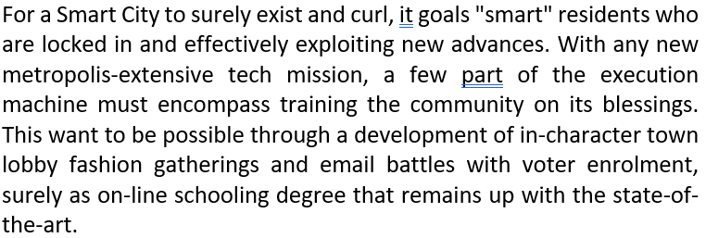

At the problematic even as a network looks like it's far having an effect within the trendy choices that impact each day lifestyles, and is being conveyed to in an unmistakable and aware way, it's far often nicely-best to utilize the innovation and urge others to utilize it furthermore. This is important to a Smart City's prosperity.

## 9.5 Being Socially Inclusive

Smart travel programs that give riders constant updates are a good thought for a clamoring city. Yet, imagine a scenario where a large portion of the number of inhabitants in that city can't bear to take mass travel or Uber. Shouldn't something be said about a developing old populace that doesn't utilize cell phones or applications? By what method will smart innovation reach and advantage these gatherings of individuals?

## 

## 10. Conclusion

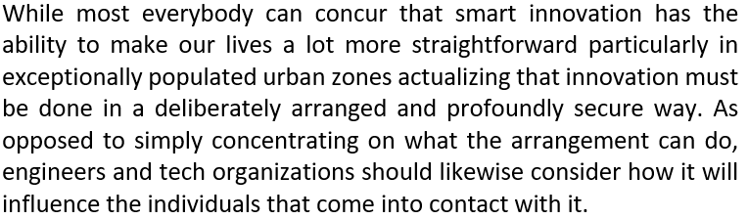

At the element while innovation, town control, and networks of people join up to enhance the personal satisfaction for each person included, that is the point at which a metropolis honestly becomes "smart."

**11. References**

1. <https://esa.un.org/unpd/wup/publications/files/wup2014-highlights.pdf>
2. <https://www.un.org/development/desa/en/news/population/world-population-prospects-2017.html>
3. <http://www.sciencedirect.com/science/article/pii/S2095809916309420>.
4. <http://www.sciencedirect.com/science/article/pii/S2542660518300519>.
5. <http://smartcities.ieee.org/about.html>.